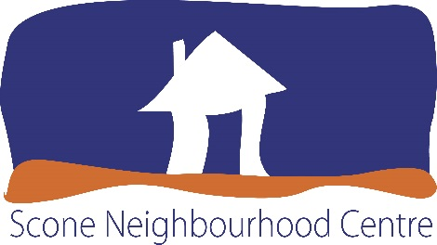
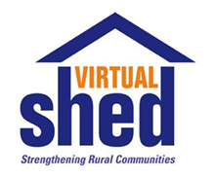

MEDIA RELEASE – Immediate

DARREN FLANAGAN ‘The Gun’ TO MAKE AN IMPACT ON THE UPPER HUNTER
THIS FATHER’S DAY WEEKEND

The Scone Neighbourhood Resource Centre’s Virtual Shed Project will welcome Darren Flanagan to the Upper Hunter on Saturday 3rd September 2016.
Darren gained national recognition though his role in the Beaconsfield Mine disaster. He systematically detonated the 70 explosives that would eventually free Webb and Russell. Darren has recently been presented with the National Bravery Award Medal and is very candid about the impact of the Beaconsfield Mine disaster on his life and those at the mine. His story is amazing, reverting, and unforgettable and should not be missed.
Project Officer Belinda McKenzie said “The Virtual Shed Project is very lucky to have secured Darren to visit Scone with his incredible story. He is passionate in his belief that an open camaraderie between men is essential for good health and wellbeing which sits nicely with our Men’s Health Project. I urge all members of the community to take the opportunity to engage in the evening and hear this inspirational and genuine storyteller of life experience.”
Although a donation at the door is requested; seat bookings need to be secured before the evening by calling the Scone Neighbourhood Resource Centre on 6545 2562 or logging on to www.snrc.com.au/ select Virtual Shed Tab/ then select Darren Flanagan. Both ladies and gentleman are welcome to attend the evening that will be held at the Scone Bowling Club at 6.30pm.

For more information contact Virtual Shed Project Officer, Belinda McKenzie on 0499 057 255
or email belinda@snrc.com.au
Picture: Darren Flanagan ‘The Gun’

